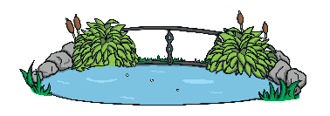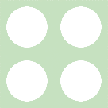



### Maths Talk and Learn: Supporting White Rose Maths Alive in 5!



## Composition of 4

How many different ways can you make four?

Explain how you know that there are four counters in each of the five frames.

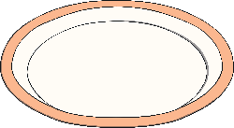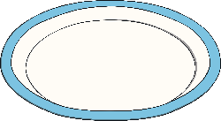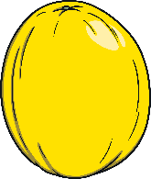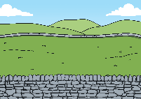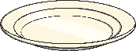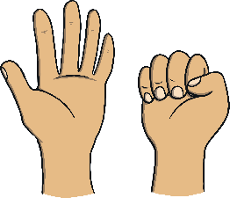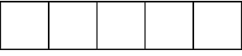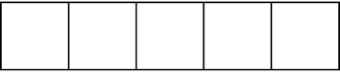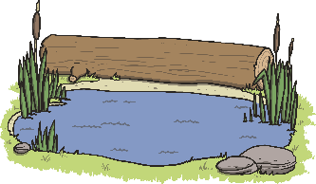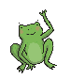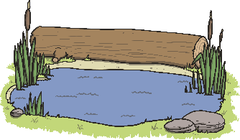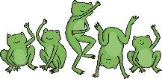

### Challenge Yourself:

* Throw four or five balls of socks into a pan.   
  How many land in the pan   
  and how many land out?   
  How many altogether?

## Comparing Numbers to Five

When comparing one quantity to another, it can be

**more than fewer than the same as**

Compare the quantities of biscuits on each plate.

Are the biscuits shared fairly?

Hold up two fingers on one hand. On the   
other hand, show me more than two fingers.   
Then, show me fewer than two fingers.   
Finally, make the amounts equal on both   
hands. Is there more than one way to   
complete each step?

Which pile of fruit has more?

## Zero

**all gone one less than one none**

All of these pictures show zero.

How many ducks are in each pond? Which one shows zero?

**Five Currant Buns in the Baker's Shop**

How many buns are left in the baker shop at the end of the song?

### Challenge Yourself:

* Roll a die, then use toys to show an amount that is more, fewer or the same as the number rolled.
* Sort a set of dominoes into two piles. One pile that shows dominoes with equal amounts on each side and another pile which shows more and fewer.

## Composition of 5

How many different   
ways can you make   
five?

**Five Little Speckled Frogs**

How many frogs are in the pool each verse and how many are on the log? How many altogether?

### Challenge Yourself:

* Sing ‘Five Little Men in a Flying Saucer’ and count back each verse until there are zero.
* Go on a hunt around the house to find different representations of zero, e.g. an empty biscuit tin, the zero numeral on a cooking dial.

## Compare Mass

**full nearly full half full nearly empty empty**

Talk about the size and shape of these containers.

Use some of these words**: tall thin narrow wide shallow**

Which container do you think might hold the most?

Compare the contents of each container.

Look at how many ladles it took to fill each container. Which container has the greatest capacity? Then order them from smallest capacity to the greatest.

## Compare Mass

**heavy heavier than heaviest light lighter than lightest**

**equal to**

Talk about what these balance scales show.

Bigger items are not always heavier. Smaller items are not always lighter.

Which item is the heaviest? Which is the lightest? How do you know? Put the items in order of lightest to heaviest.

### Maths Talk and Learn: Supporting White Rose Maths Alive in 5!



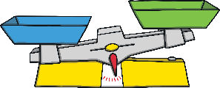

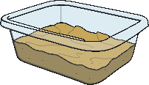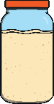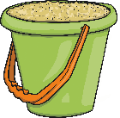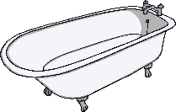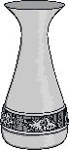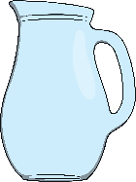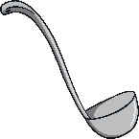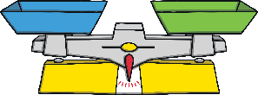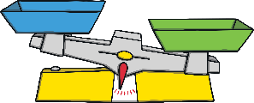

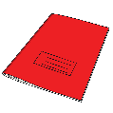

### Challenge Yourself:

* Select a cup. Count how many tablespoons it takes to fill your cup. Now, how many teaspoons does it take? Which spoon was the quickest to fill the cup?
* Fill an empty jar with water. Then, find a container that holds more than your jar and another container that holds less than your jar.   
  Empty the water from your jar into the containers   
  to check.

### Challenge Yourself:

* Hold and compare the weight of different packages of items from around the house (e.g. cereal box, shoe box, bag of sugar). Which box feels the heaviest? Which box feels the lightest? Are bigger boxes always the heaviest?
* Find something heavier than an egg. Find something lighter than an egg. Find something smaller but heavier than an egg.