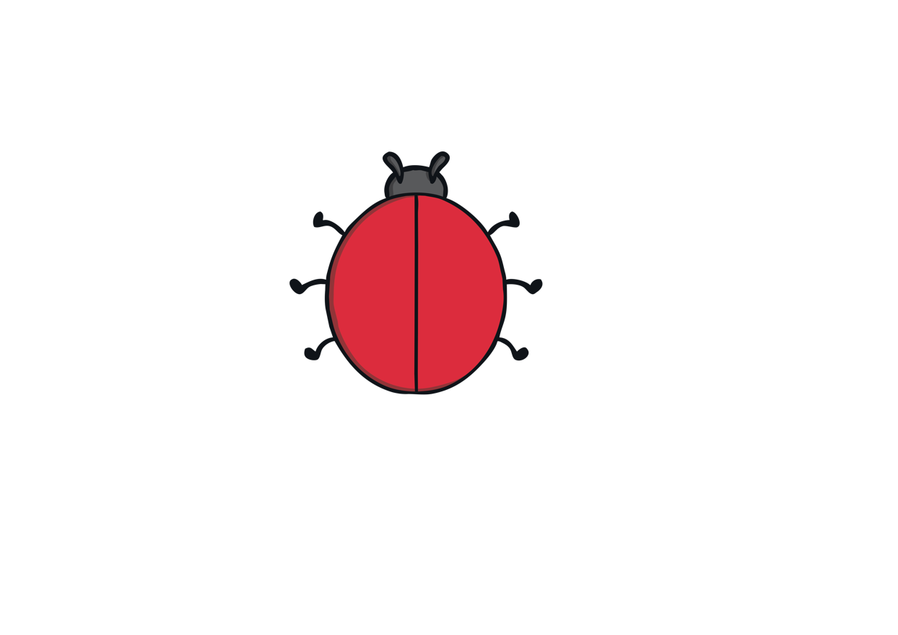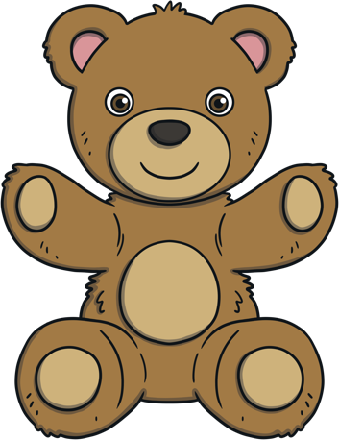

## Deepening Understanding

**Different possibilities** means finding more than one way to solve a problem.

**A combination** is when 2 or more things are put together to make a group.

**Total** means how many all together.

There are lots of vehicles on the playground, it’s getting very busy! Can you tell me how many wheels there are all together?

If there were only 3 vehicles on the playground, how many wheels would there be? Is there more than one answer?

### Challenge Yourself:

* Make some skittles using six cardboard tubes. Write the numerals 1, 2 and 3 on them so you have two skittles of each number. Bowl three balls at the skittles. How many points did you score? Can you record your score? How many ways could you score 6 points? What is the highest score you could get? What is the lowest?

Teddy is thinking of some 2D shapes. All together they have 7 sides. Can you tell me which shapes Teddy might be thinking of? Is there more than one possibility?

Can you point to 2 ladybirds with a total of 6 spots? Can you find more than one way to make 6?

**Maths Talk and Learn: Supporting White Rose Maths On The Move**

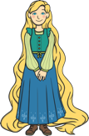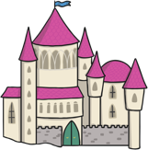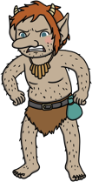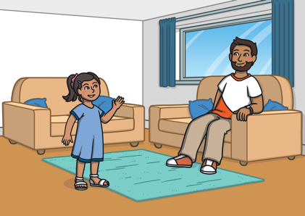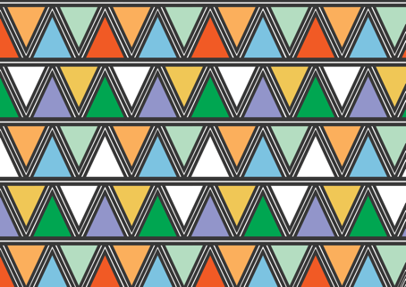



### Challenge Yourself:

* Can you build or draw a maze for one of your small world toys? Place the toy in the middle of your maze. Can you tell your grown-up how they will find their way out?

### Challenge Yourself:

* Can you create a repeating pattern using three different types of objects, such as natural materials, buttons or coins?
* Can you make your pattern reach all around the edge of a plate?

**Spatial Reasoning: Mapping**

**map             direction                 forwards                   turn               pass**

**first                  then                 next                 near              far**

Can you tell me how you get from your   
living room to your bedroom?

Can you tell me how you get from your   
classroom to the school hall?

Which direction do you need to go in   
first? What do you pass first? What do   
you pass next?

Can you tell me how Rapunzel can get from the river to her castle? What will she pass? Is there more than one way to get there? Which way might the troll go to get to the castle?

**Patterns and Relationships**

**Symmetrical Pattern**

One alien has popped out of the crater.   
How many feelers does he have? Now   
another one has popped out. How many  
feelers are there now? If one more alien   
pops out, how many feelers will there be   
all together? Can you spot the pattern?   
What is happening to the numbers?

Can you match each sandcastle to its symmetrical other half?

What do you notice about these patterns?

What shapes can you see?

Which colours have been used?

**Maths Talk and Learn: Supporting White Rose Maths On The Move**